Cách impdp

* **Để xem các directory hiện có trong database:**

Desc dba-directories ;

Tạo Source scrip ls.sql :

|  |
| --- |
| colu OWNER format a10  colu DIRECTORY_NAME format a25  colu DIRECTORY_PATH format a75  set pagesize 100  set line 200  set verify off  define vname='&1'  select OWNER,DIRECTORY_NAME,DIRECTORY_PATH  from dba_directories  where DIRECTORY_NAME like upper('%&vname%')  order by 2  / |

Sau đó chạy scrip :

@ ls %

Bước 1 : tạo thư mục lưu trữ file import

mkdir /home/oracle/imp_demo

chown -R oracle:oinstall /home/oracle/imp_demo

bước 2 : cho file cần import vào thư mục đó



chown -R oracle:oinstall /home/oracle/imp_demo/ivr-06032023.dmp

Bước 3 : tạo directory

create directory imp_demo as '/home/oracle/imp_demo';

* **Để xem các directory hiện có trong database:**

Desc dba-directories ;

Tạo Source scrip ls.sql :

|  |
| --- |
| colu OWNER format a10  colu DIRECTORY_NAME format a25  colu DIRECTORY_PATH format a75  set pagesize 100  set line 200  set verify off  define vname='&1'  select OWNER,DIRECTORY_NAME,DIRECTORY_PATH  from dba_directories  where DIRECTORY_NAME like upper('%&vname%')  order by 2  / |

Sau đó chạy scrip :

@ ls %

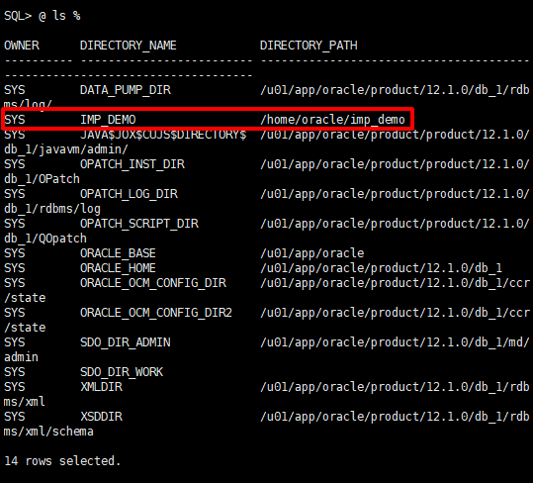

Bước 4 tạo user và cấp quyền dùng để import

|  |
| --- |
| create user thangmta63 identified by ducthangdtvt17;  grant connect, create session, imp_full_database to thangmta63;  grant dba to thangmta63; |

Bước 5 : tạo user ivr-new cho fie ivr-06032023.dmp

create user IVR_NEW identified by ducthangdtvt17;

Bước 6 : tạo tabespace :

CREATE TABLESPACE PROFILE_DATA DATAFILE 'profile_data.dbf' SIZE 100M AUTOEXTEND ON NEXT 10M MAXSIZE UNLIMITED;

Bước 7 : chạy lệnh impdp :

impdp thangmta63/ducthangdtvt17 directory=imp_demo dumpfile=ivr-06032023.dmp logfile=imp.ivr-06032023.log remap_schema=ivr:ivr_new



